# BENGBENG - cross-country form

The communication between mobile APP and BENGBENG is Bluetooth communication.

The Bluetooth module on BENGBENG is Bluetooth 5.0.

## Install BENGBENG - cross-country form

Please open the installation guide and follow the steps to install.



### APP download and installation

Android APP download: Search for straysnail in Google play

Or directly use the installation package provided by us:

|  |
| --- |
|  |

IOS APP download：Search for straysnail in APP store

**APP interface introduction：**

Select the product on the left side of the APP interface, select Beng beng in the figure below, and then click the Bluetooth button.

|  |
| --- |
|  |
|  |

### Read the APP values

Note: Because Bluetooth is serial communication, using Arduino 0 (Rx) and 1 (Tx) pins, and using USB data cable to upload programs is also serial communication, if you turn on the Bluetooth switch, the upload program will fail, so remember to turn off the Bluetooth switch when uploading programs.

|  |
| --- |
| Push it to the ON side to turn on Bluetooth |

1. **Example program**

|  |
| --- |
|  |

1. **Experiment operation and phenomenon**
2. Open the mobile APP, and click the button of BENGBENG.

|  |
| --- |
|  |

1. **Click the Bluetooth button to enter the control interface.**

|  |
| --- |
|  |
|  |

1. **Connect the Bluetooth**

The Bluetooth module we use is low-power Bluetooth 5.1, and the device name is BT-24 or JDY23.  
In order to make it more convenient to use, and to cope with the situation that we do not know which Bluetooth ID is our own when multiple Bluetooth devices with the same name are nearby, We have added the proximity connection function to the APP.

### Proximity connection

Turn on the power of BENGBENG and make sure that the light of the Bluetooth module is flashing, which means that there is no connection.  
Open the mobile APP to the control interface, close to BENGBENG, and then click the search connection button. You will soon see that the mobile interface prompts that the connection is successful automatically. Android APP needs to click the space next to it to return to the control interface. Then look at the Bluetooth module LED. If it is always on, it means that the connection is successful.

|  |
| --- |
|  |
|  |

* 1. **Manually select the connection**

Turn on the power of BENGBENG and make sure that the light of the Bluetooth module is flashing, which means that there is no connection.

|  |
| --- |
|  |

* 1. **Turn on the Bluetooth switch of BENGBENG**

After the APP is successfully connected to the Bluetooth, remember to turn on the Bluetooth switch, otherwise it will not be able to communicate.

|  |
| --- |
|  |

### SnailBlock prints the received data

Click the button on the APP control interface or drag the virtual rocker to see the received data printed by the SnailBlock serial port monitor.

|  |
| --- |
|  |

## APP controls the LED

In the previous section, we learned the value of each APP button, and we can see that the sent value is $ sign start * sign end.

The value of the on LED button is $a *, and the value of the off LED button is $b *. It can be seen that the main command values are a on LED and b off LED.

Therefore, we need to take the values which are removed the $ and *.

1. **Example program**

|  |
| --- |
|  |

1. **Experiment phenomenon**

After the APP successfully connects to the BENGBENG Bluetooth, turn on the Bluetooth switch, click the LED button once, and the LED light will light up, and click again, it will turn off.

|  |
| --- |
|  |

At the same time, you can see that the data received by the SnailBlock serial port monitor is a and b.

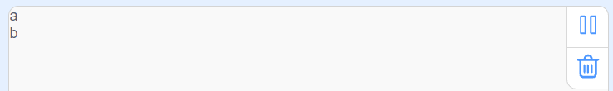

## Bluetooth remote control vehicle

We use the values of the virtual rocker to control the movements of BENGBENG. The corresponding values of the movement directions are:

|  |  |  |  |  |
| --- | --- | --- | --- | --- |
| F | B | L | R | S |
| Forward | Backward | Turn left | Turn right | Stop |

1. **Example program**

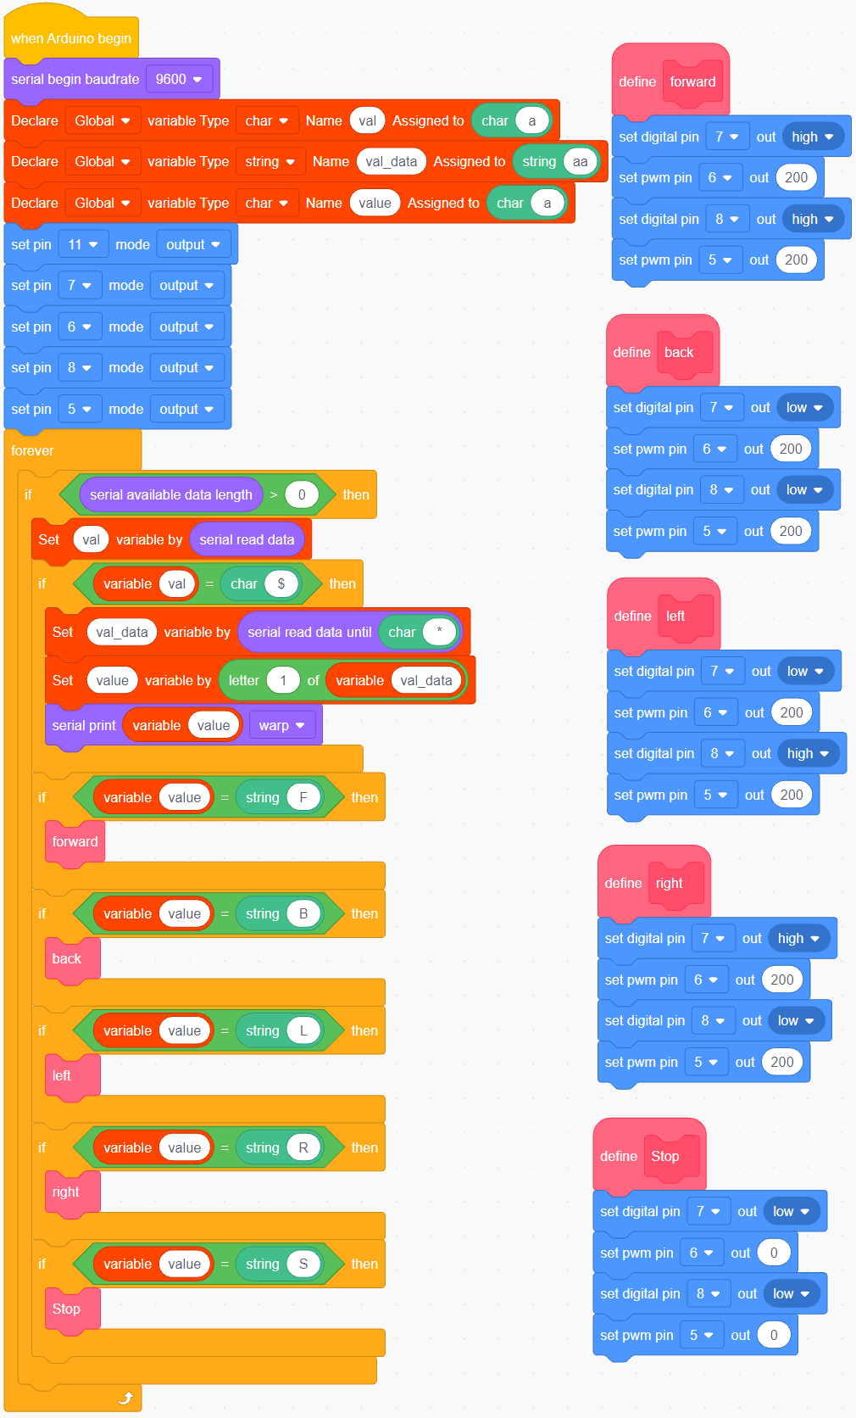

1. **Experiment phenomenon**

Drag the virtual rocker on the APP interface to control the movements of the vehicle.

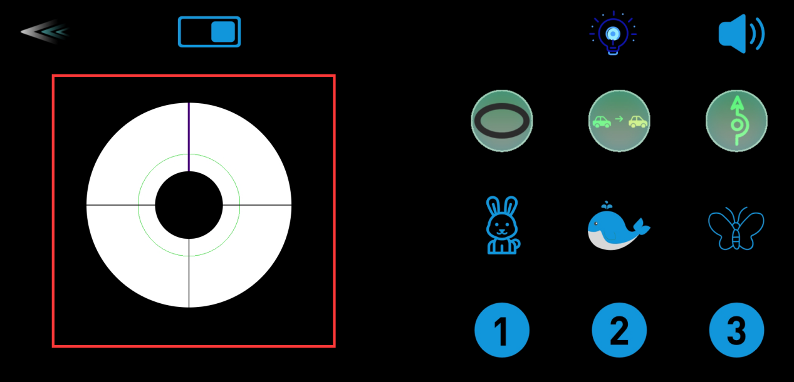

## Multi-function Bluetooth remote control vehicle

Write a program to integrate the main functions of BENGBENG, controlling and switching the functions through APP.

1. **Program idea**

First of all, we need to know the value of each button of the APP. Then judge that different values are received to control different functions.  
The functions of tracking, following and obstacle avoidance can only be realized by entering the cycle program block, and then setting the function of exiting the current cycle after receiving the specified signal value.

1. **Example program**

The program is relatively large. Please open the example program provided by us.

|  |
| --- |
|  |

1. **Experiment operation and phenomenon**

